Introduction
This document describes the design of the Rainwater Harvesting System.
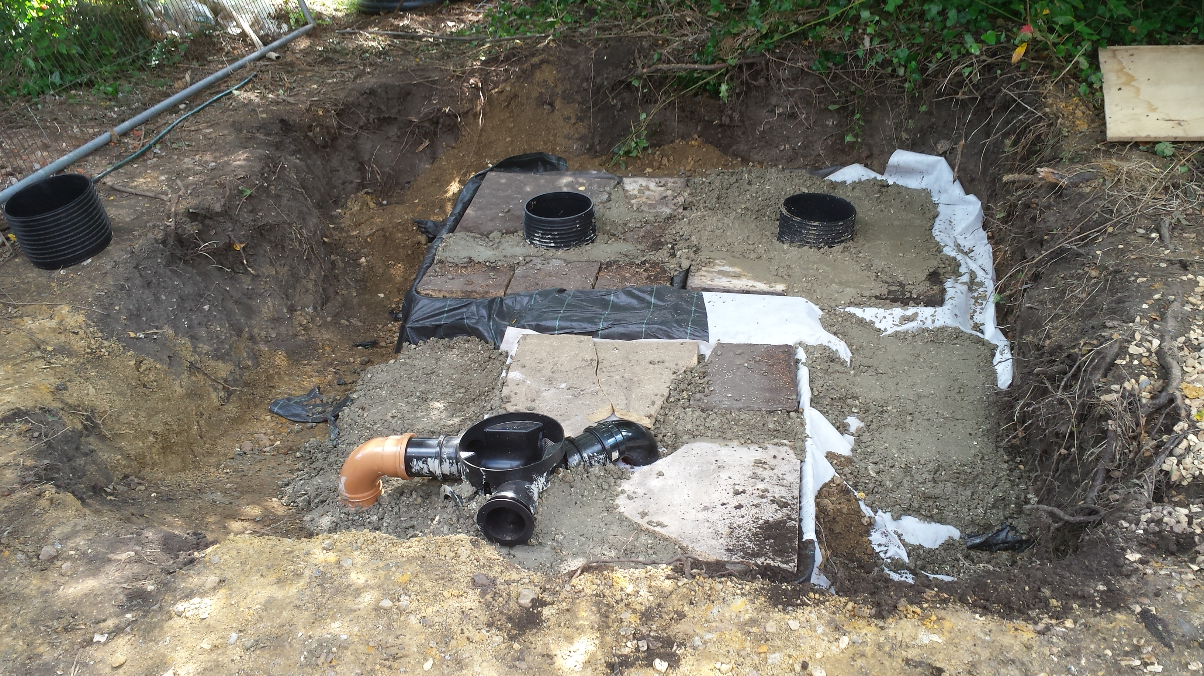
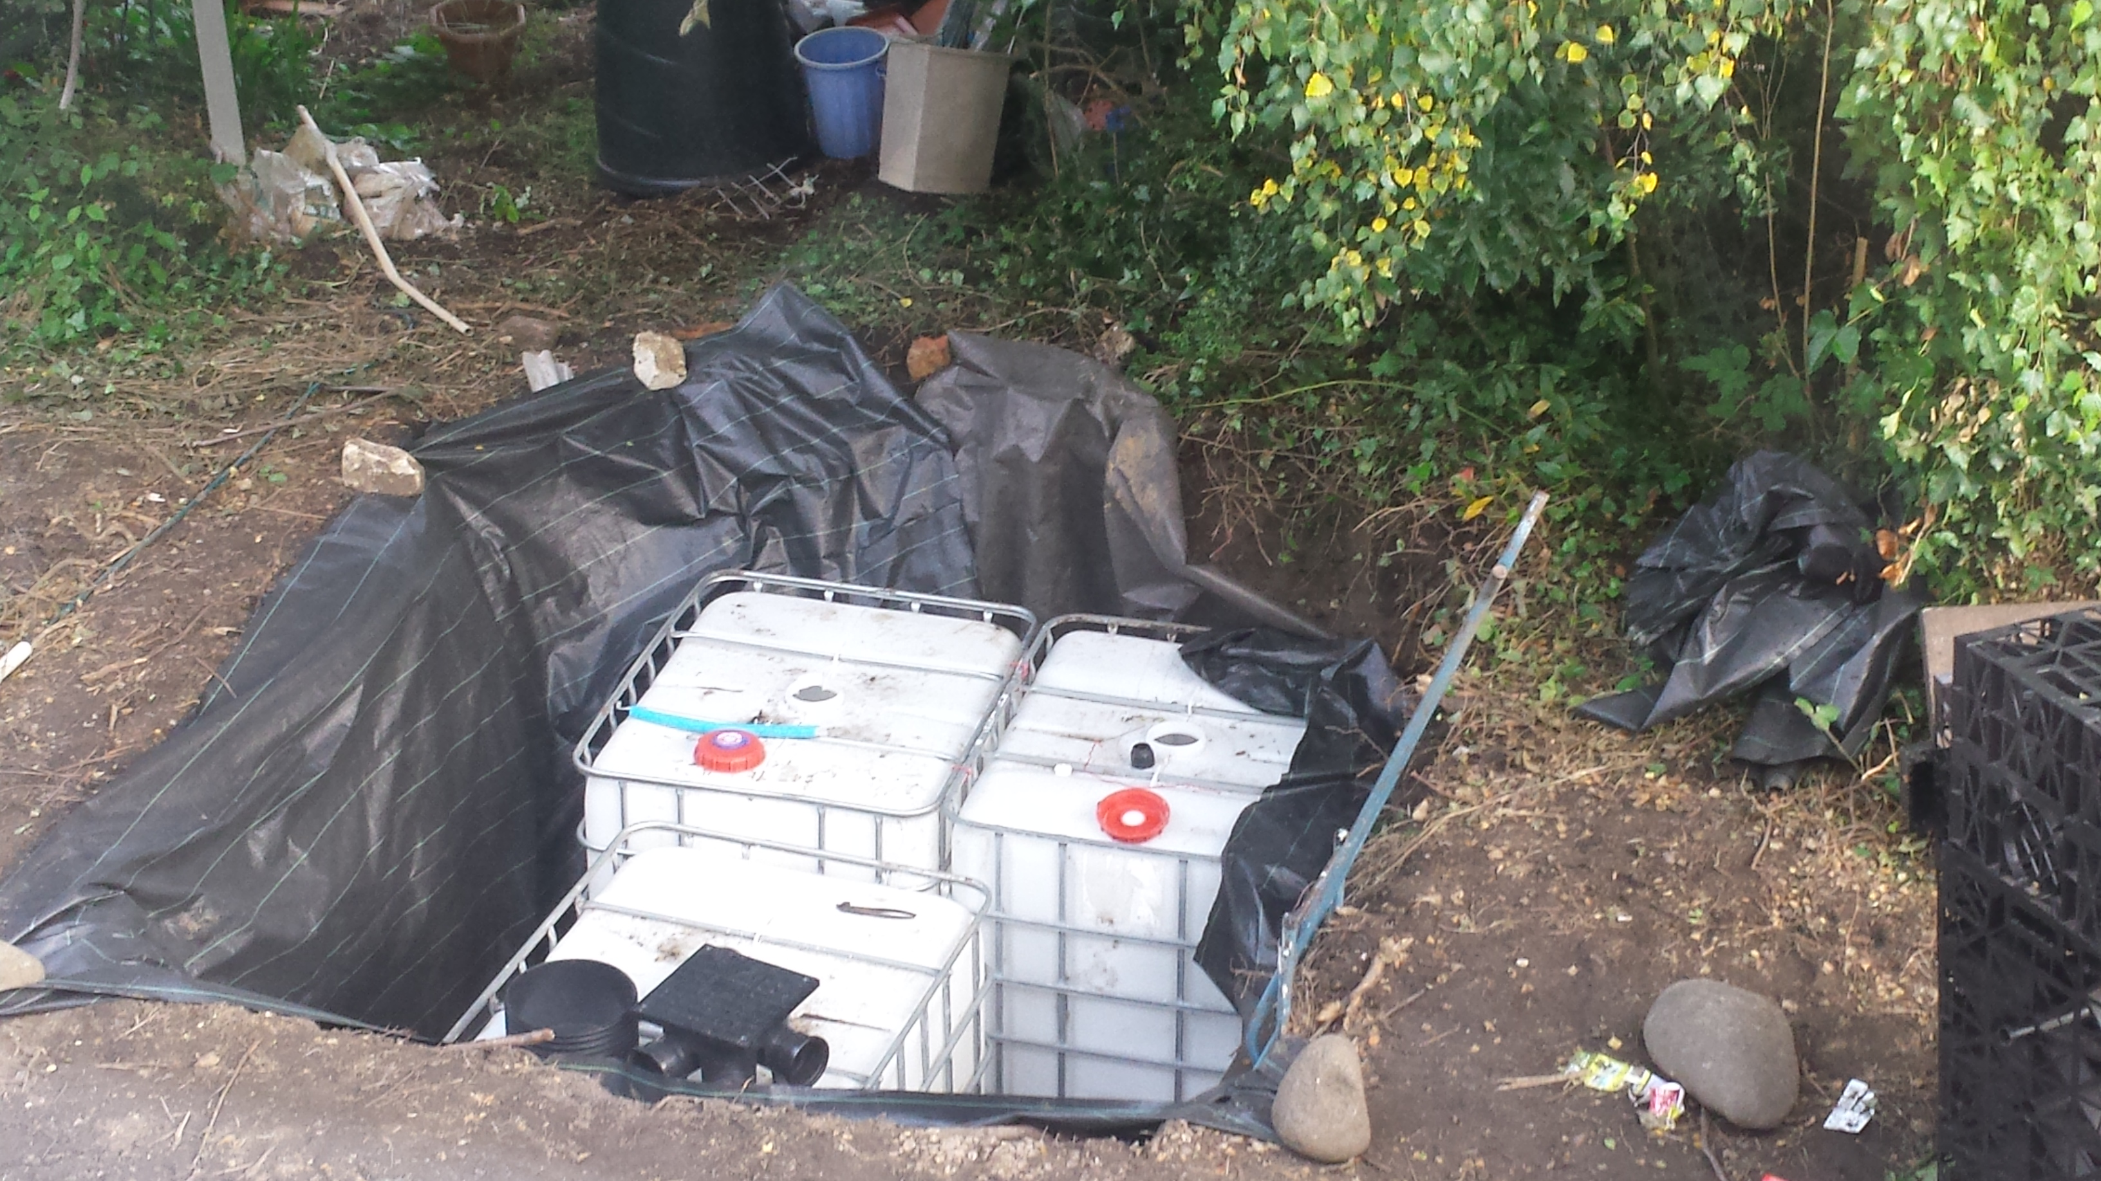
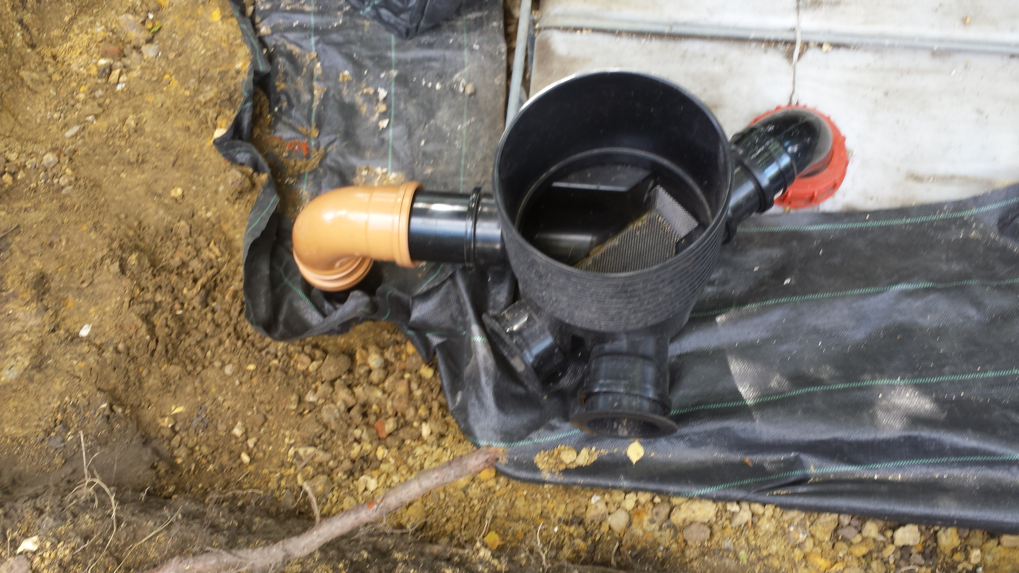
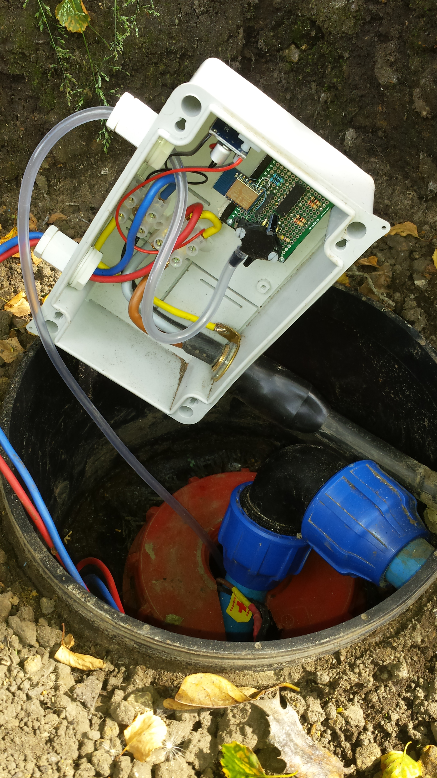
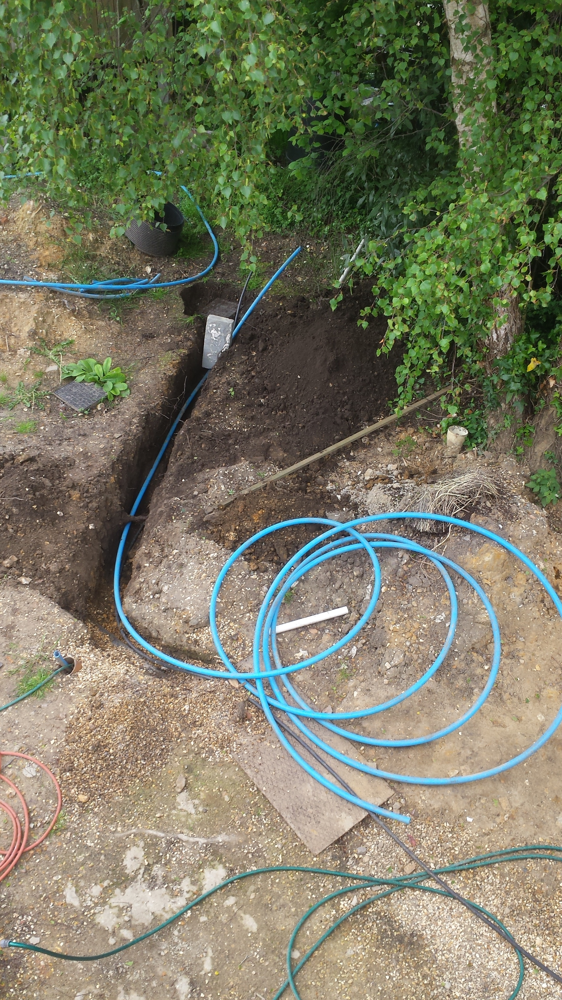
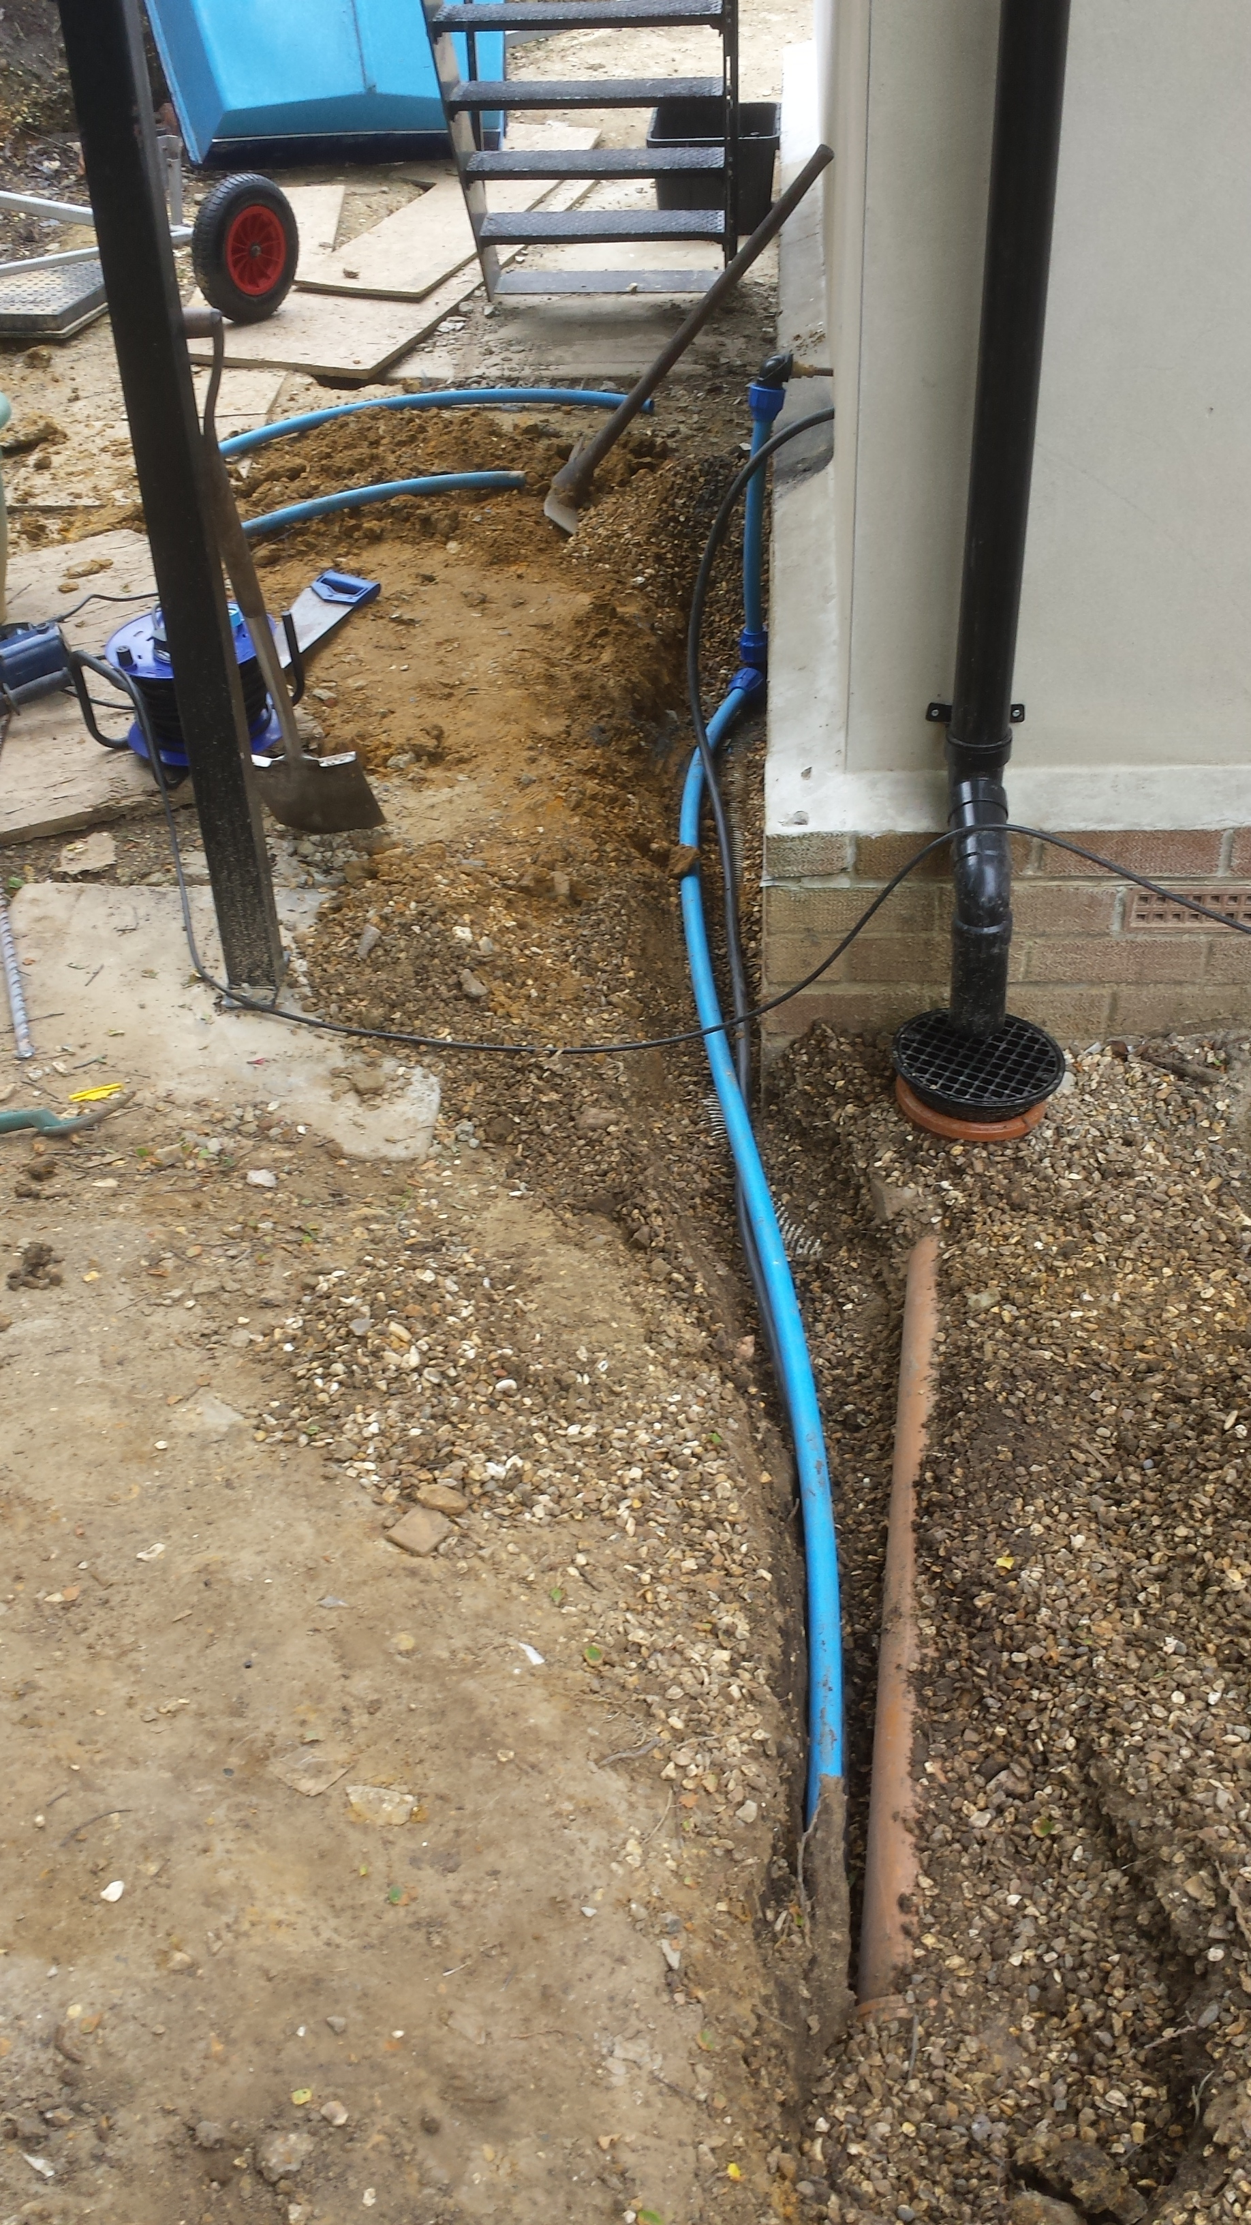
These pictures show the 3 IBC 1000l tanks in the ground by the silver birch tree. The hole is lined with geotextile fabric and the tanks are covered with slabs and concrete to protect them from digging. All 3 tanks are interconnected and the one on the far left has the opening left open with an inspection chamber riser for the pump and level sensor. Rainwater is taken from the balcony via 110mm underground drainage pipe to the nearer tank via another inspection chamber (3rd picture) which incorporates a mesh filter to minimise the amount of leaves etc ending up in the tanks.
The 4th picture shows the box containing the Level sensor and wiring to the 12V pump. The latter feeds the water via 50mm MDPE pipes to the house.

System Diagram
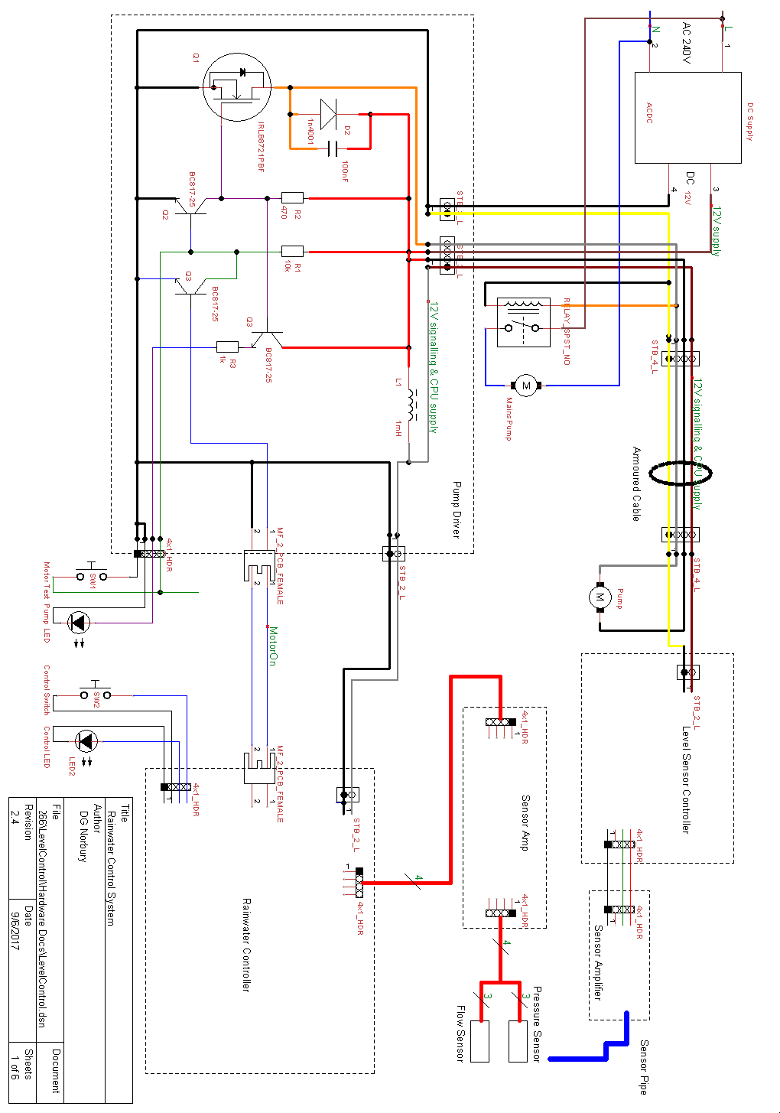
The system has the following main building blocks:
- Rainwater Controller
- Pump Driver
- 12V Power Supply
- Pressure sensor amplifier
- 12V Pump
- 240V pump
- 240V pump relay
- Level sensor
- Pressure Vessel
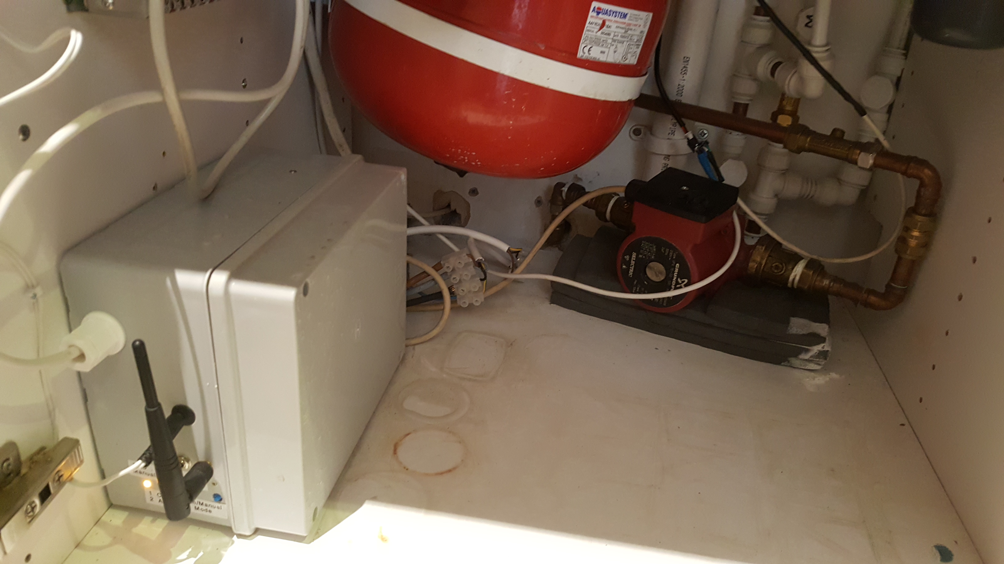
12V supply to catch
Pressure vessel
240V pump
Connection to pump
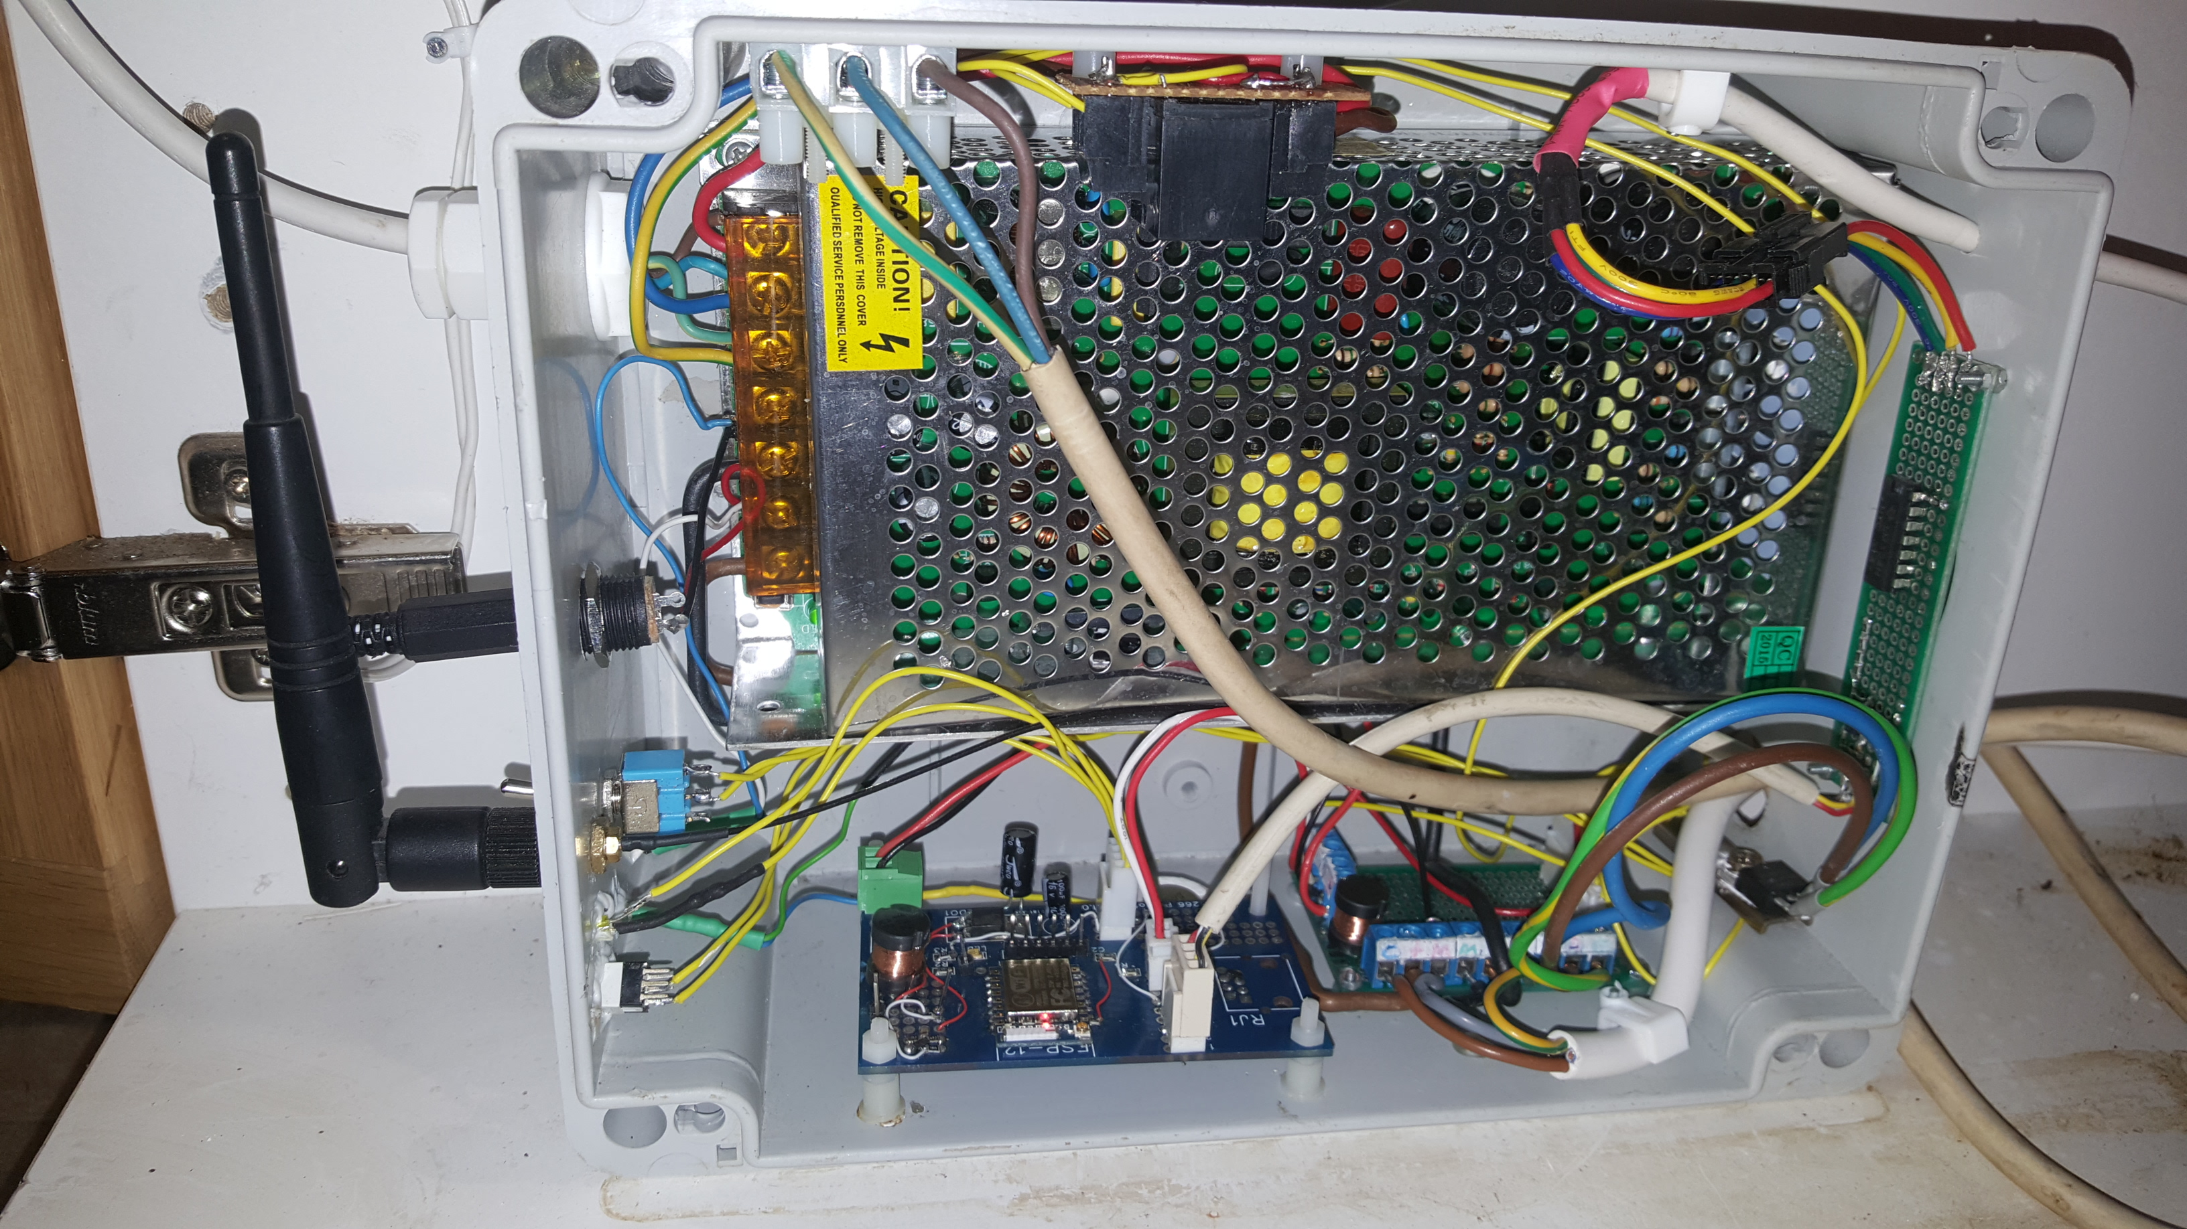
Rainwater Controller
Pump Driver
Water Pressure sensor Amp

Pipework
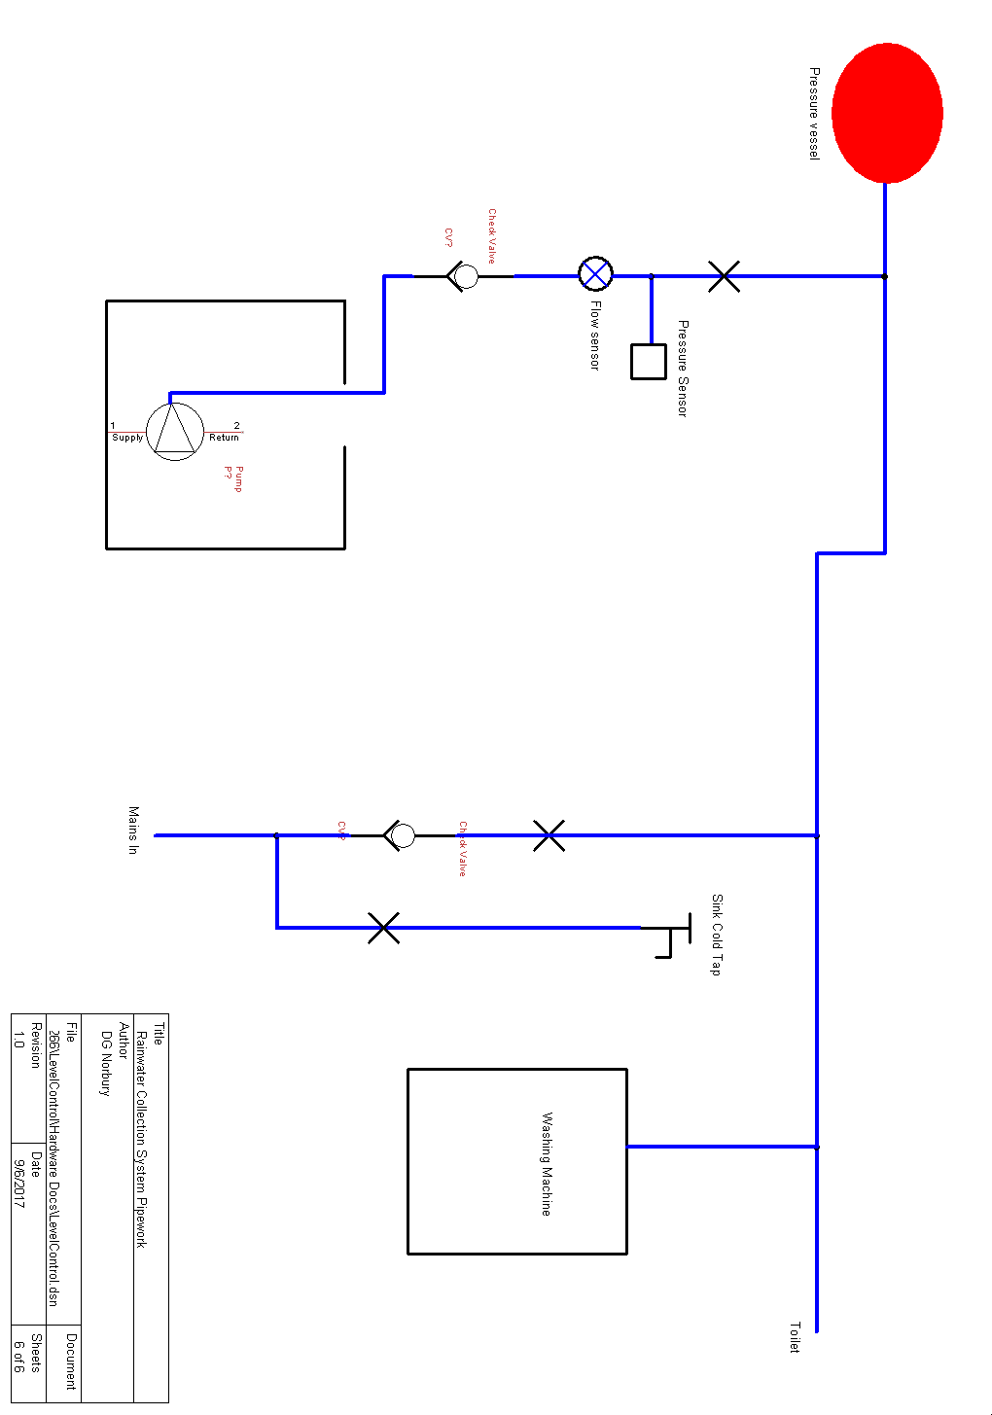

Rainwater Controller
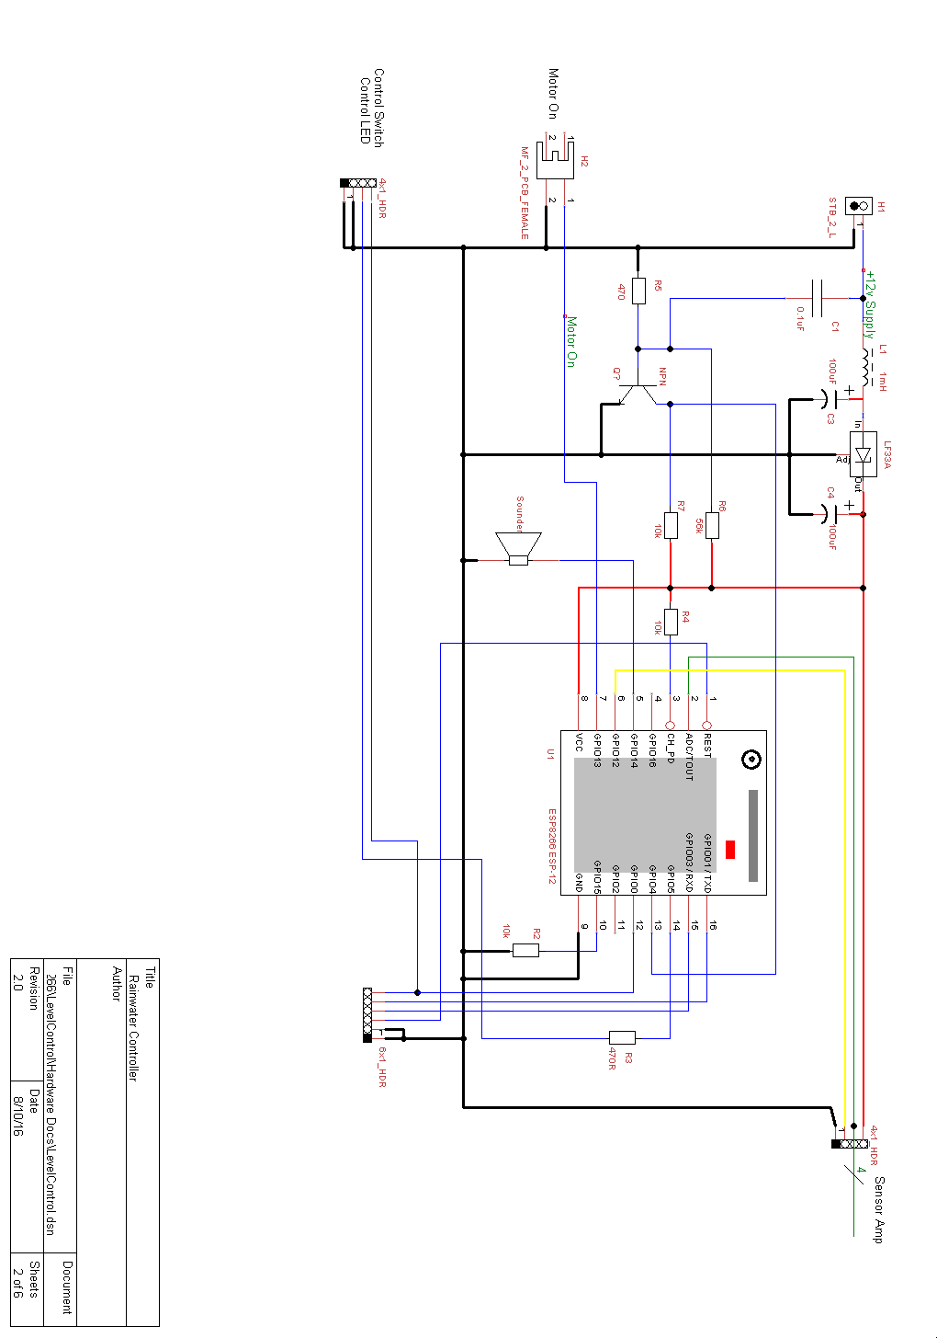

Level Control Water Level Sensor
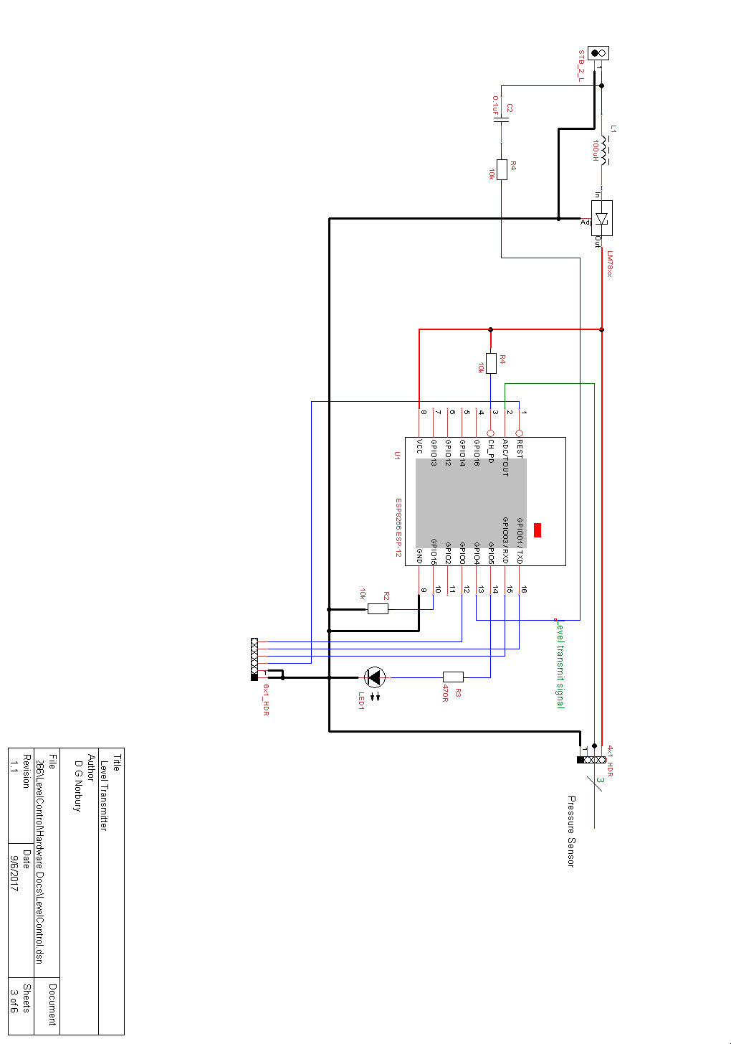

Water Level Pressure Intrumentation Amplifier
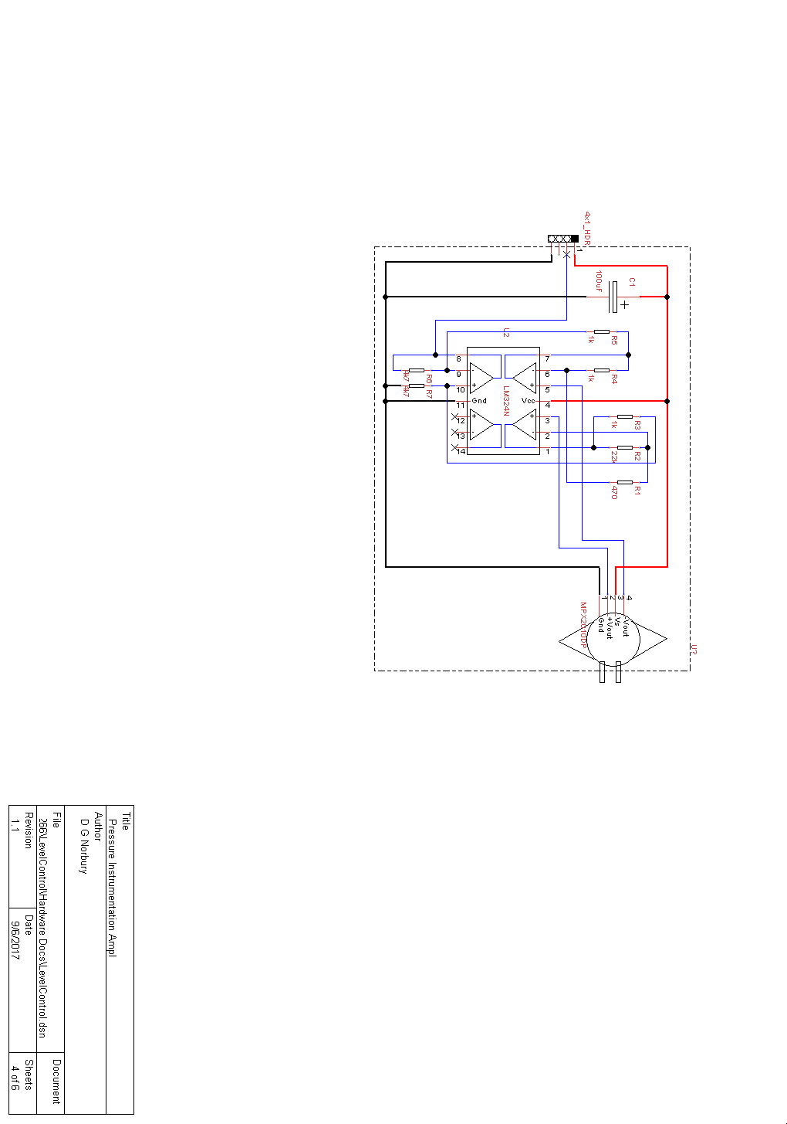

Water Pressure Sensor Amplifier
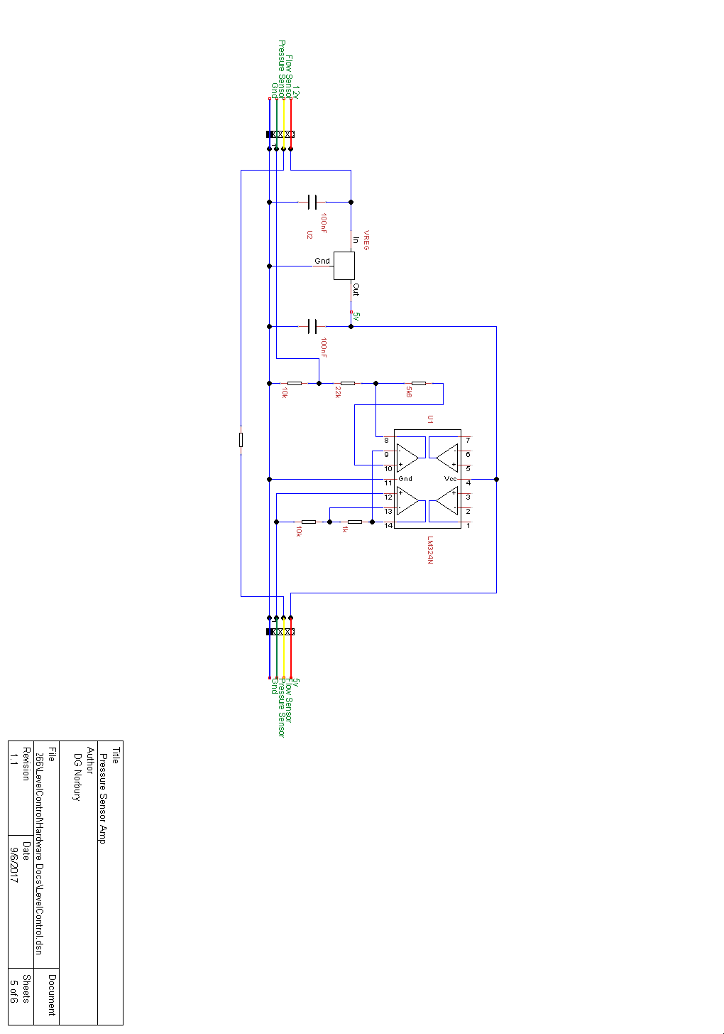

Signalling between Level Sensor and Rainwater Controller
Due to the difficulties of getting WiFi reception in the pump access chamber and the lack of a specific signalling cable the tank water level data is transmitted over the DC supply wire.

The key design principle is that the level data is transmitted once per second with an 8 byte frame format.
- 0xaa
- Level₈₋₁₆
- Level₀₋₇
- Sumcheck (1+2+3)
Each bit is transmitted as a group of 6 pulses (or absence of pulses) with a period of 200uS.
- groupStart 0b101011
- groupBit0 0b101111
- groupBit1 0b110101
- groupEnd 0b101101

The frame is started with 'groupStart' and terminated with 'groupEnd'.

Rainwater Controller

This unit:
- Monitors the water pressure
- Monitors the flow rate
- Receives the water level data
- Operates the pumps when the pressure is below the set minimum
- Turns off the pump when the pressure reaches the set maximum
- Turns off the pump if there is no flow after 10S of the pump operating
- Sends the pressure, flow rate, water level and pump operating to the database via MQTT
There is a manual mode to turn the pump on/off if required.

There are a number of control settings:
- Pump ON – pressure below which the pump will turn ON (195)
- Pump OFF - pressure above which the pump will turn OFF (290)
- Flow Time – (10)
- Flow per Litre – How many pulses from the flow sensor indicate 1 litre (450)
- Low pressure warning
- Low level warning
- Max Pump ON warning - # seconds that pump can be on before a warning message is sent (4200)
- Max Pump ON error - # seconds that pump can be on before error condition is raised, system put into manual mode and alarm sounded (5400)
- No flow Auto error (20)

